Lab 03

Logical Operations

Lab Objectives
By the end of this lab, students will be able to:
- Understand the role of logical and bitwise operations in the ALU.
- Perform simple bit-level manipulations using assembly instructions.
- Relate assembly instructions to the behavior of digital logic gates studied in Digital Logic Design.

Introduction: In this lab, students will explore logical and bitwise instructions in assembly language. These instructions are directly related to the logic gate operations performed inside the ALU (Arithmetic Logic Unit) of the processor. Each operation works on binary data bit by bit, just like AND, OR, and NOT gates in digital circuits.
The following instructions will be practiced:
- AND – logical AND operation, result bit is 1 only if both bits are 1.
- OR – logical OR operation, result bit is 1 if either bit is 1.
- XOR – exclusive OR, result bit is 1 if the two bits are different.
- NOT – bitwise inversion (1’s complement).
- SHL (Shift Logical Left) – shifts bits left, often used for multiplying by powers of 2.
- SHR (Shift Logical Right) – shifts bits right, often used for dividing unsigned numbers by powers of 2.
- ROL (Rotate Left) – rotates bits left, MSB moves into LSB.
- ROR (Rotate Right) – rotates bits right, LSB moves into MSB.
These instructions are essential because they represent how the processor’s ALU performs logical decision-making, data manipulation, and efficient arithmetic operations.
AND Example (Declared in Decimal)
MOV AL, 05h ; AL = 05h = 00000101b
MOV BL, 04h ; BL = 04h = 00000100b
AND AL, BL ; AL = 00000100b = 04h

AND Example (Declared in Binary)
MOV AL, 00000101b ; AL = 5
MOV BL, 00000100b ; BL = 4
AND AL, BL ; AL = 00000100b (4)
Output
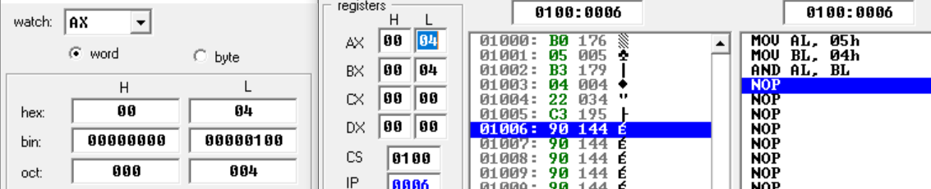
OR Example
MOV AL, 00000101b ; AL = 5
MOV BL, 00000100b ; BL = 4
OR AL, BL ; AL = 00000101b (5)

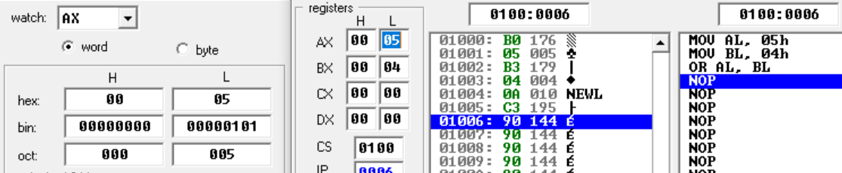
NOT Example
MOV AL, 00000101b ; AL = 00000101b
NOT AL ; AL = 11111010b
Output
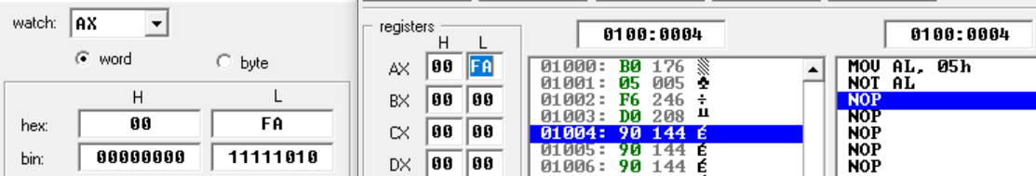
XOR Example
MOV AL, 00000101b ; AL = 5
MOV BL, 00000100b ; BL = 4
XOR AL, BL ; AL = 00000001b (1);

Output
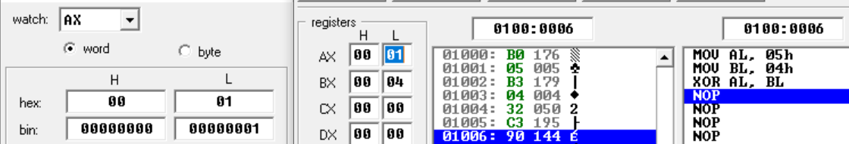
Shift Registers Example
; --- SHL Example ---
MOV AL, 00000101b ; AL = 5
SHL AL, 1 ; AL = 00001010b (10)

; --- SHR Example ---
MOV BL, 00000101b ; BL = 5
SHR BL, 1 ; BL = 00000010b (2)

Output (AX)
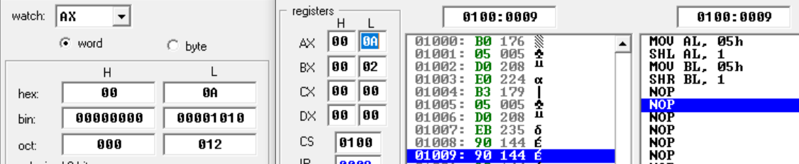
OUTPUT (BX)
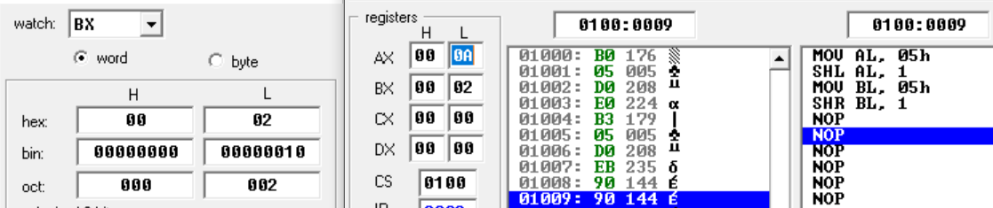

Small Applications
Even/Odd Check using AND
MOV AL, 00000101b ; AL = 5
AND AL, 00000001b ; check LSB or the result
; if result is 1 > odd else even

Output
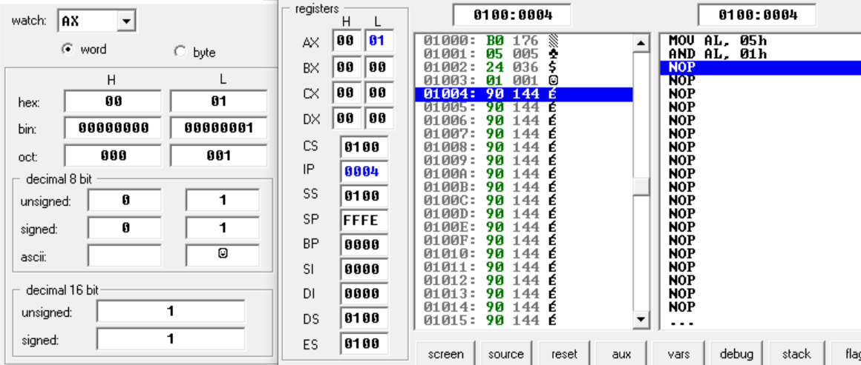
Multiply/Divide by 2 using SHL/SHR
In assembly language, the SHL (Shift Logical Left) and SHR (Shift Logical Right) instructions can be used as a quick way to multiply or divide unsigned numbers by powers of 2.
- SHL AL, 1 → shifts all bits left by 1.
  - This is equivalent to multiplying the value by 2.
- SHR AL, 1 → shifts all bits right by 1.
  - This is equivalent to dividing the value by 2
Example
MOV AL, 00000101b ; AL = 5
SHL AL, 1 ; AL = 00001010b (10 decimal, 5×2)
SHR AL, 1 ; AL = 00000101b (5 decimal, 10÷2)

Output
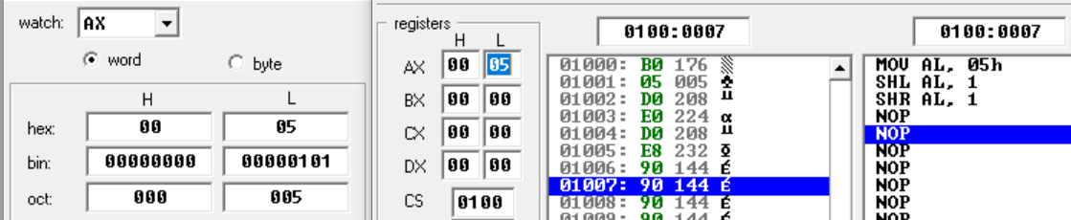
Toggle Bits using XOR (We can toggle specific bits using position of ones)
MOV AL, 10101010b
XOR AL, 11111111b ; toggles all bits

Output
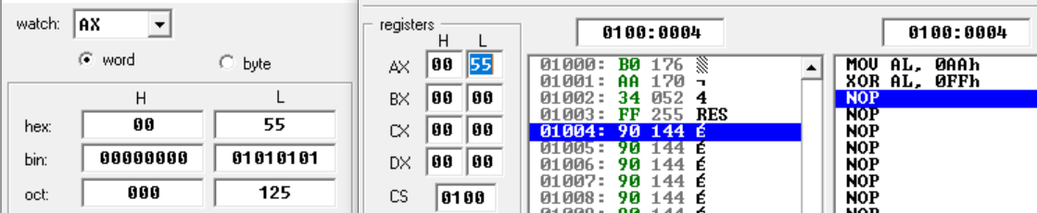

Exercise:
Task 1: Clear the register AX using the XOR operation (not by MOV AX, 0).
Task 2: Use ROL and ROR instructions in an example and explain their practical usage.
Task 3: Write assembly instructions to implement NAND and NOR gates.
Task 4: Use shift registers in bit large numbers and more practical examples.

